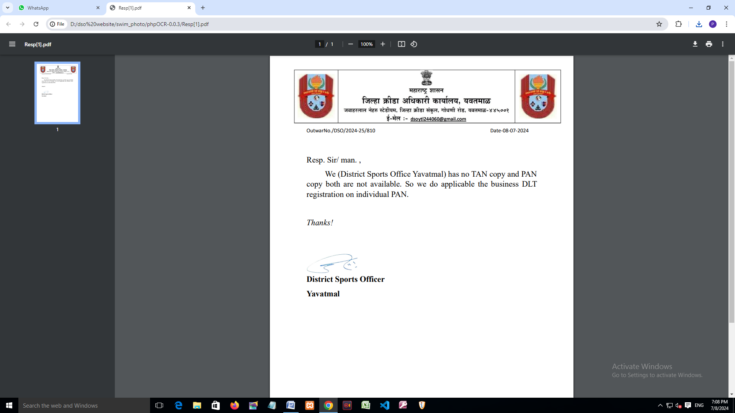

Resp. Sir.,

We have (District Sports Office, Yavatmal) TAN Certificate Copy and PAN Certificate copy has not available.

Hence, Authenticate Business DLT Registration on Individual PAN.

*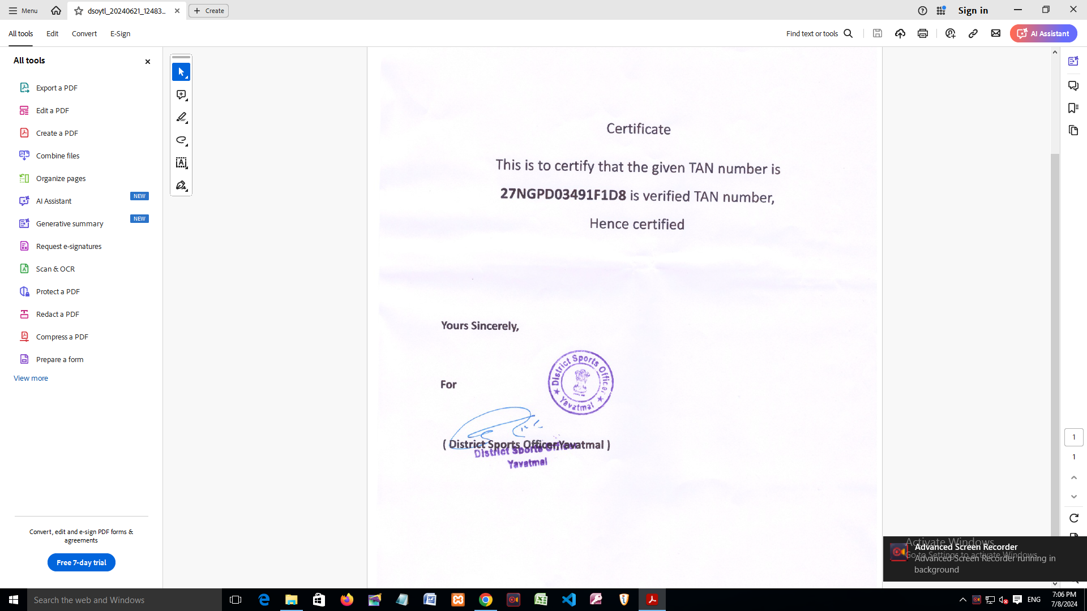Thanks !*